

**Computer & Electronic Engineering**

**Final Year Project "Music Host Interface"**

**Sprint 3: Week 3 Log**

**Thomas Flynn**

**Project Supervisor: Brian O'Shea**

**09/12/15**

**Update:**

This week I was only able reread my logs and finish my poster and block diagram.

**Tasks completed:**

Finish and print logs

Poster completed

Block diagram completed

Presentation checklist

**Board at the start of the week:**

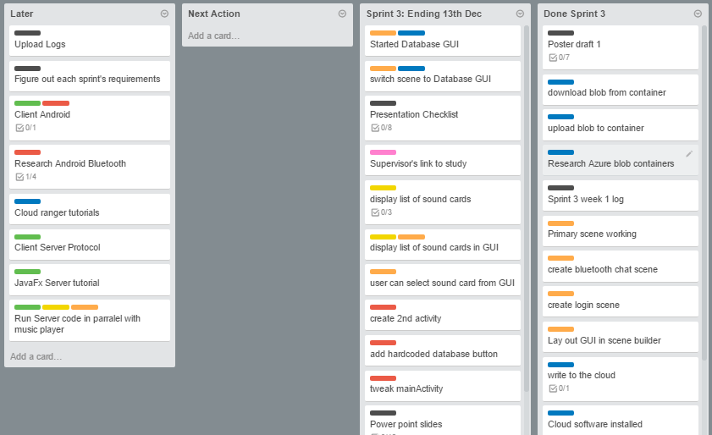

**Board at the end of the week:**

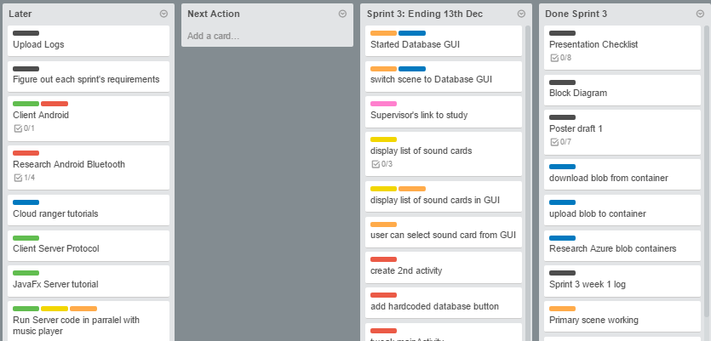

**Weekly time Log bar chart:**

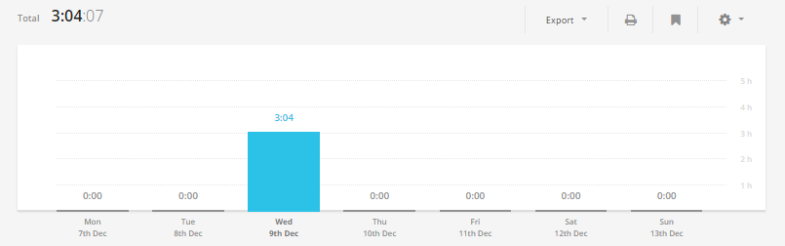

**Weekly Time Log:**

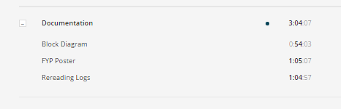

**Weekly log Pie Charts:**

